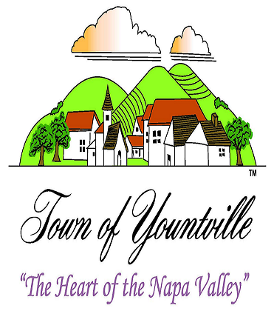

Town of Yountville Building Department
launches online building permits
Beginning July 1, 2022

As a part of our efforts to increase utilization of technology and improve customer service the Town of Yountville announces the launch of our online building permit portal. In March, the Town Council authorized Staff to work with Open Gov Citizen Services to develop a custom online building permit program. Yountville is excited to announce this transition to go to online building permit submittals, plan reviews, and inspection processes.

Minor and Major building permit plans will be uploaded electronically which will allow town staff, plan checkers, building inspectors and the applicant access to these documents via the new online portal. Plan check comments will be provided within the portal.

This change in process will provide applicants with a more efficient inter-departmental review. Inspection requests will continue to be requested via email and by voicemail and now the portal. All online building permits will be visible to the public. For the public to review they will need to set up an account. All users need to set up an account to use the portal.

Please visit our website to learn more at www.townofyountville.com or call our office at (707) 944-8851.

TO BE PREPARED PLEASE FOLLOW THE FOLLOWING STEPS:
- STEP ONE: Register for an account at the OpenGov Public Portal
Go to Town’s website for a direct link or go to https://yountvilleca.viewpointcloud.com
- STEP TWO: Follow the prompts
- STEP THREE: Upload your digital plans and submit your application
- STEP FOUR: You will receive an email confirming your application is complete for processing and a request to pay the permit fee.
- STEP FIVE: All communication regarding your building permit will be on the OpenGov Public Portal, you will receive an email when activity has happened on your account.
- STEP SIX: Inspections can be made via the portal, email to binspector@yville.com or by calling (707) 944-8851.

